**Assignment Report**

**Student Name:** Navneet P

**Student ID:** AF0411619

**Problem Statement:**

You are given a dataset which contains information about famous Hollywood movies. It includes attributes such as imdb ratings, director name, gross collection etc. Your task is to:

1. Download the dataset and remove any rows containing null data
2. Remove the special character present at the end of each movie title in the dataset.
3. Create a bar plot listing the movies made by the director James Cameron with proper labelling sorted by their IMDB ratings.
4. Extract the movie and the director’s name with the following filters:

*genre [Action], Language [English] ,Year [011-2015] ,rating [>7]*

and create an excel file displaying the result.

**You can use:**

1. Numpy
2. Matplotlib
3. Pandas
4. PowerBI(optional)

**Expected Output:**

1. A bar plot listing the movies made by James Cameron sorted by their IMDB ratings.
2. An excel file containing the filtered data according to the specified filters.

**Solution:**

Step 1: install pandas using pip install pandas. Once installed, read the dataset using the [read_csv()](https://pandas.pydata.org/docs/reference/api/pandas.read_csv.html) method.

Code:



Step 2: In the movie title column, remove the unnecessary character. Also, remove the rows containing null values(NaN). [[Dropna](https://pandas.pydata.org/docs/reference/api/pandas.DataFrame.dropna.html)]

After analysis, it turns out the character present at the end of each Movie title is “\xa0”.

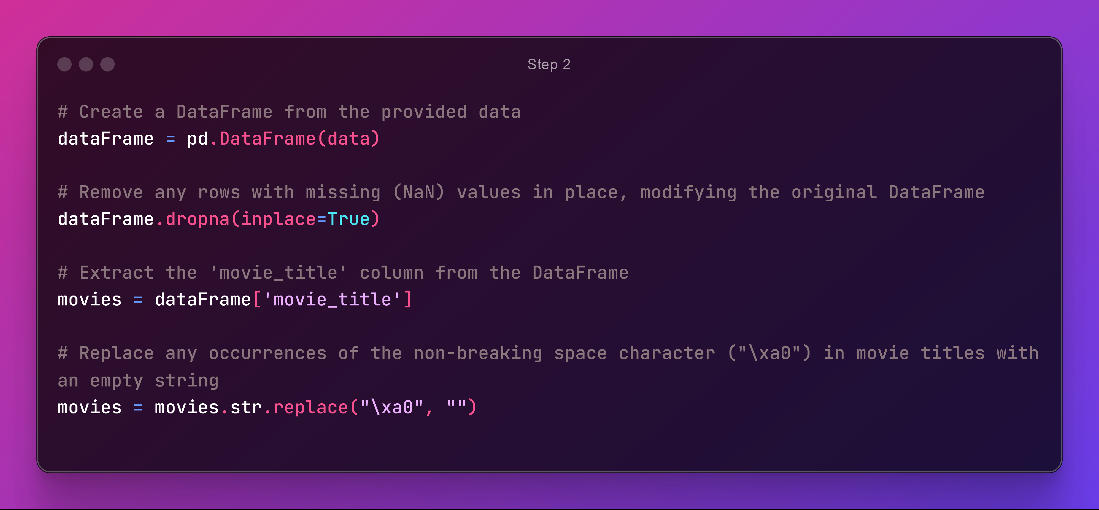

Step 3: Remove columns C – H

Since, we do not want to go back to the excel file again and again to look for the corresponding attributes to be removed, we will simply obtain the attribute columns using pandas. [[Character Indexing](https://stackoverflow.com/questions/5927149/get-character-position-in-alphabet)] [[Drop Columns](https://pandas.pydata.org/docs/reference/api/pandas.DataFrame.drop.html#pandas.DataFrame.drop)]

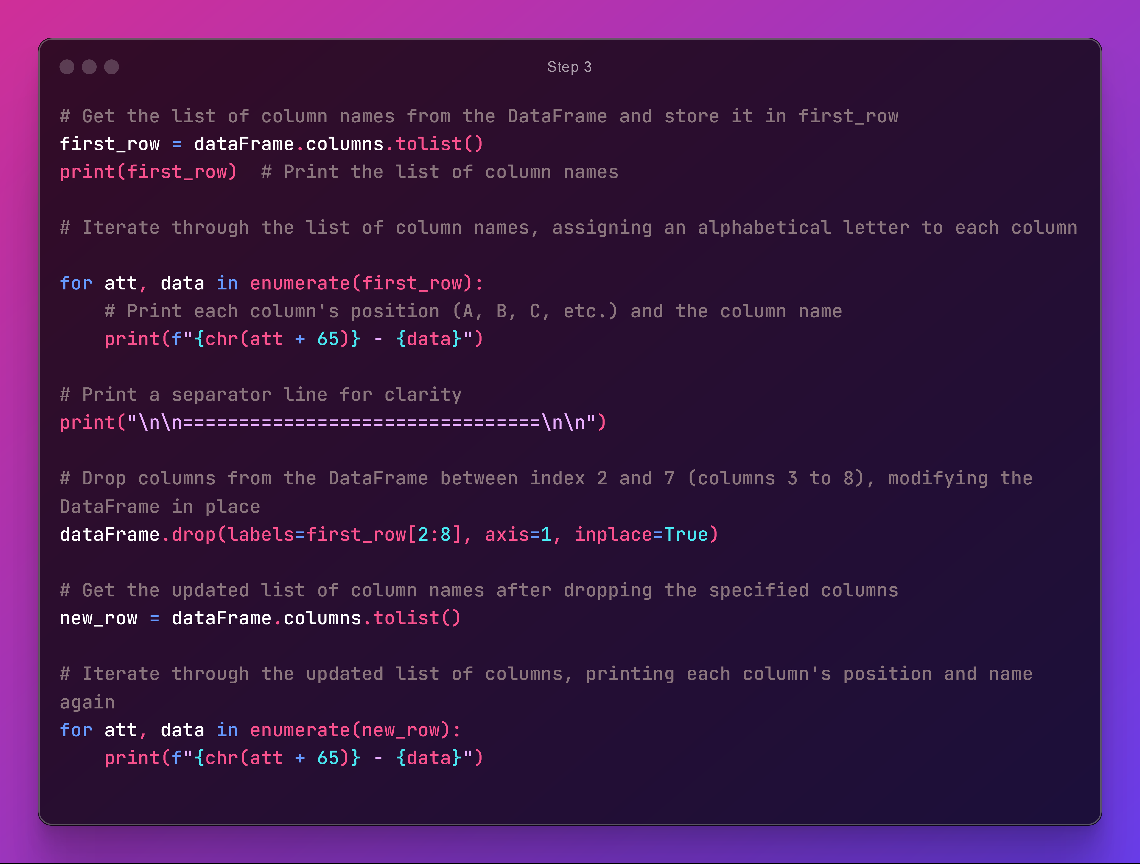

Output: List of all attributes

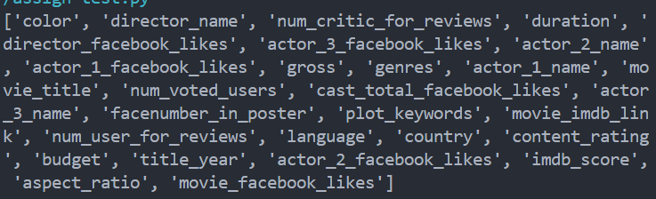

Before columns were removed After Columns are removed

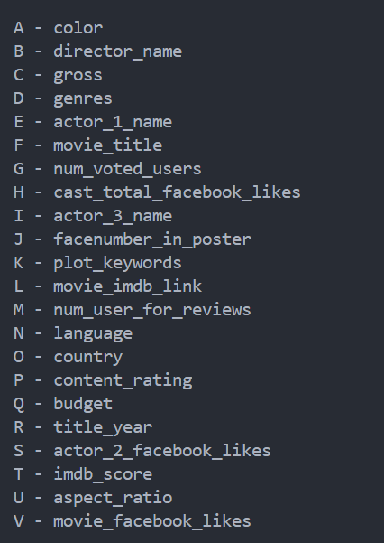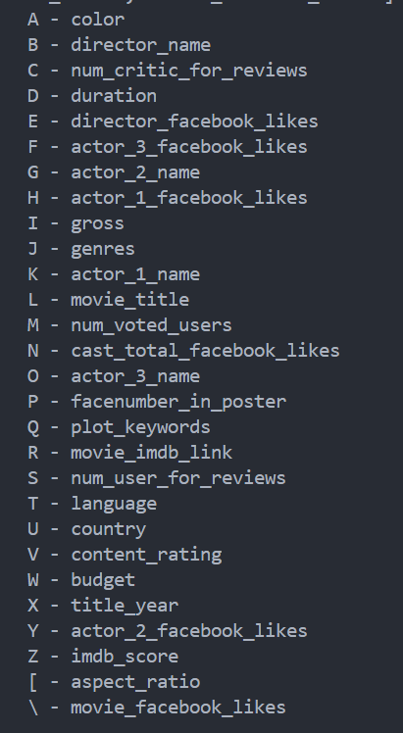

With this, the columns from C-H have been dropped.

Step 4: Filter director_name column with “James Cameron” and construct a bar plot where all his movies are sorted according to IMDB ratings. [[Zip Func](https://docs.python.org/3.3/library/functions.html#zip)]

Creating the required arrays first... 

Output: Movies array and the ratings array

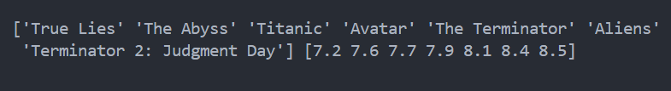

Step 5: Construct a bar plot using this data.



Output:

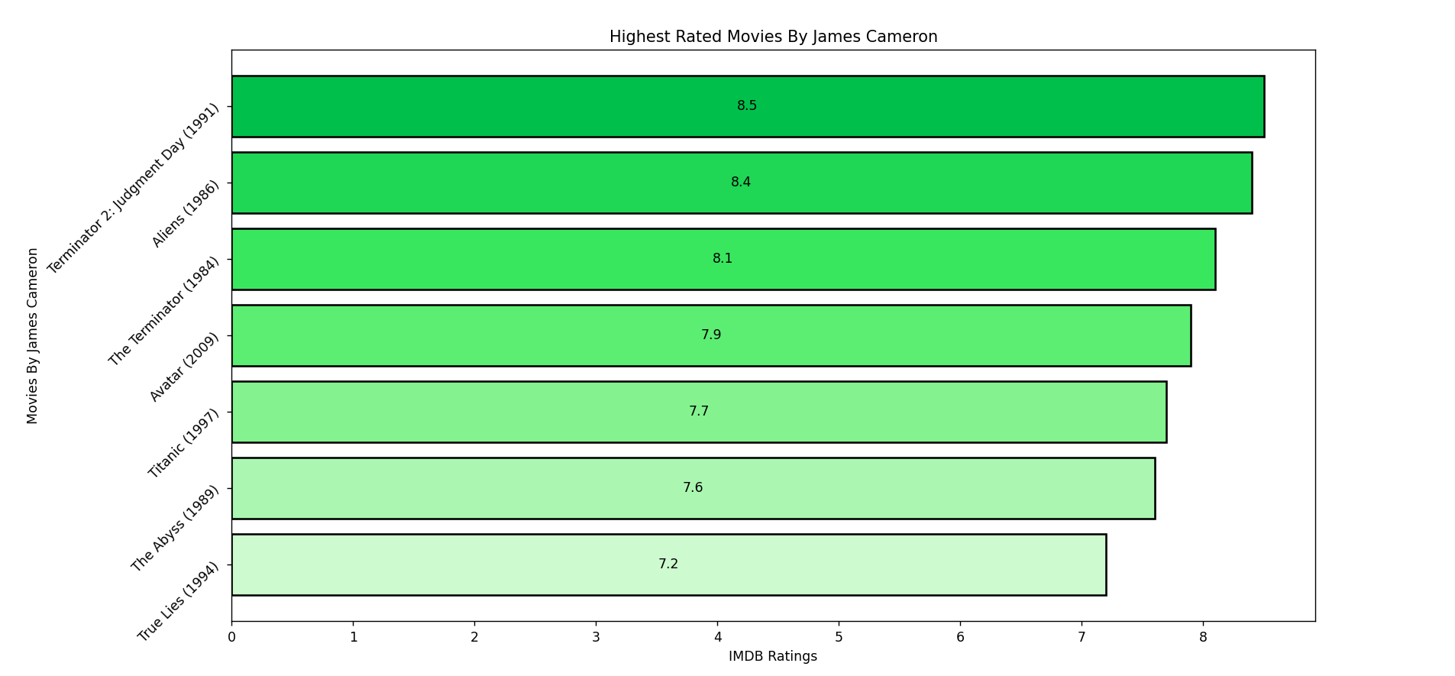

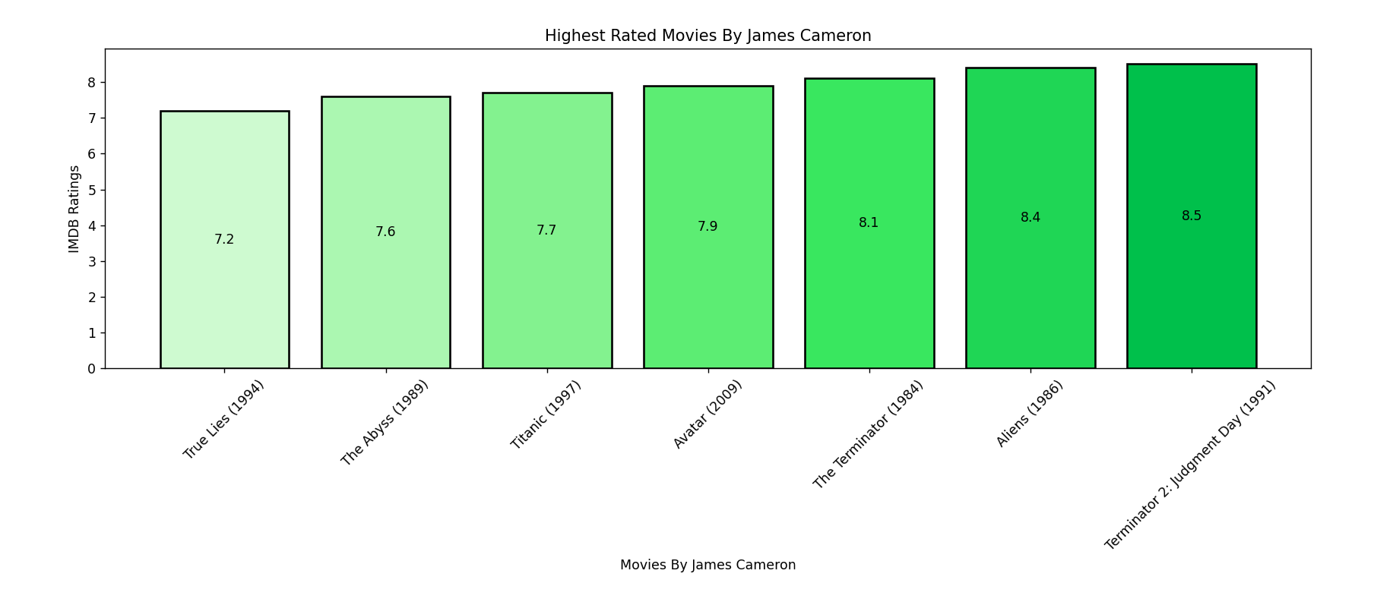

Step 6: Obtain the filtered data according to the requirements and exporting it into an excel file.

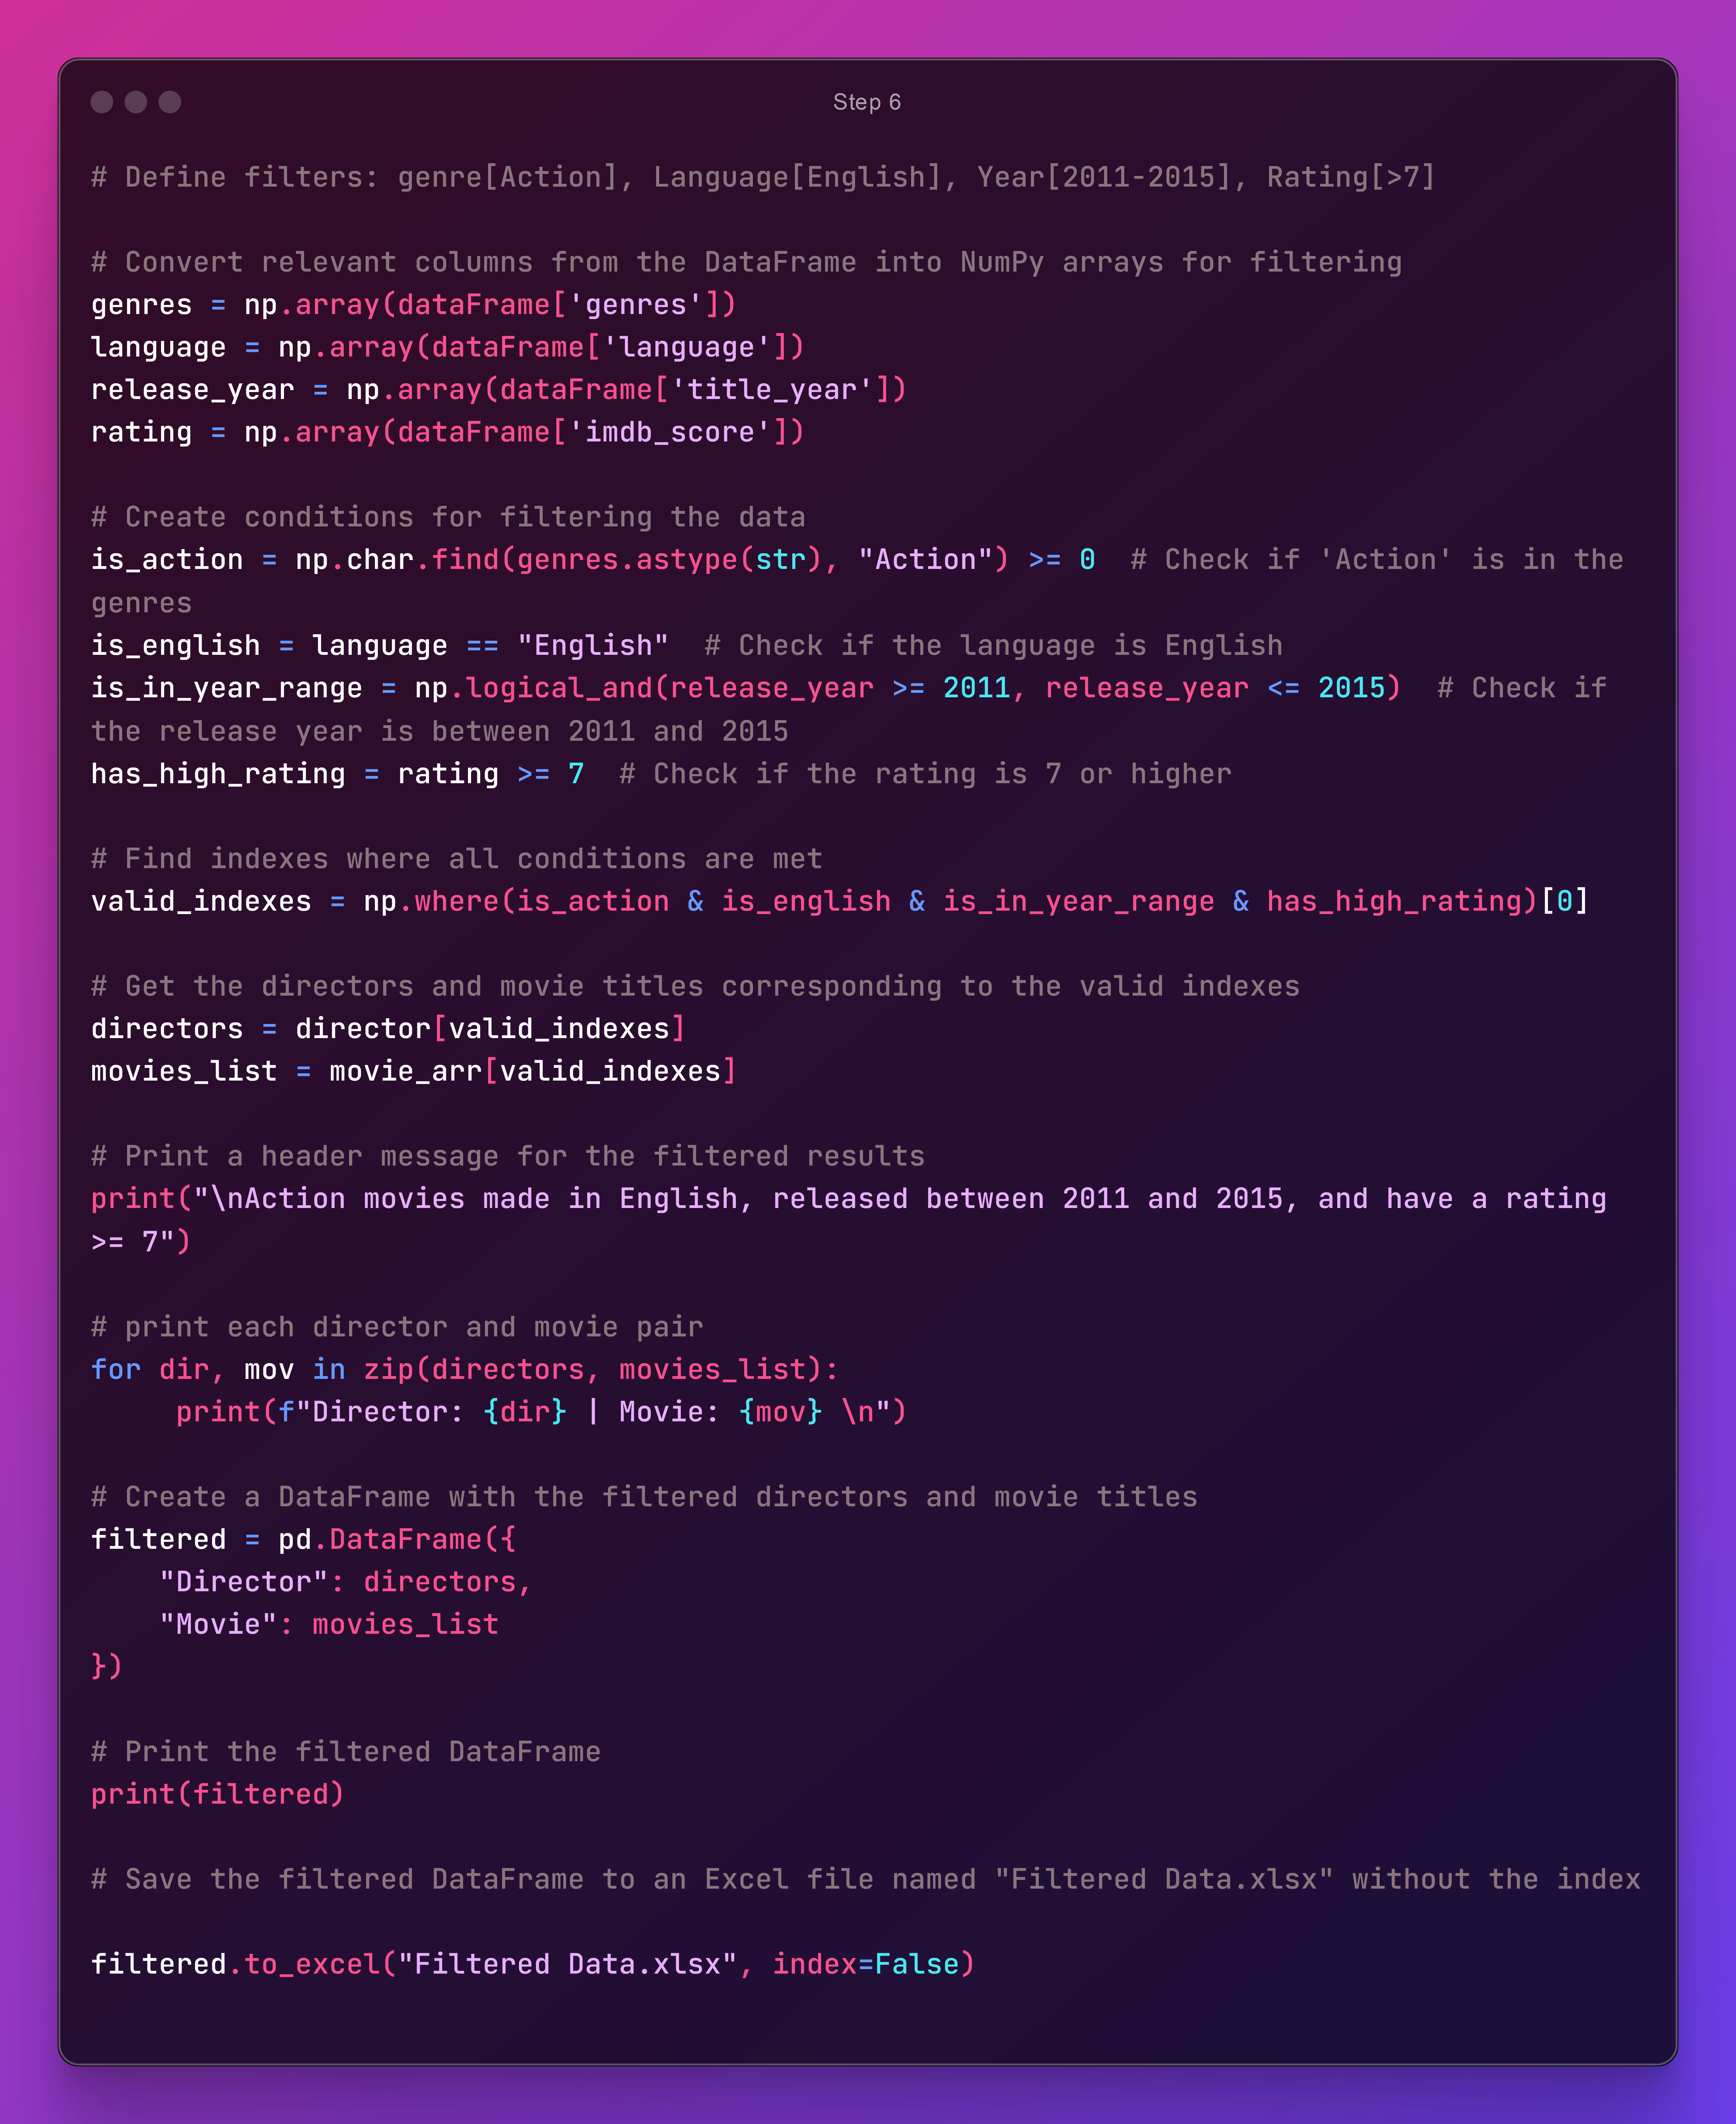

Output:

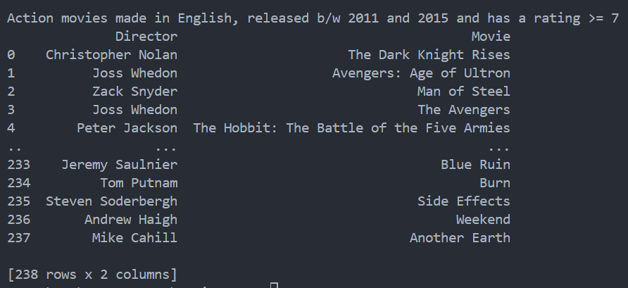

Showcase of Filtered Data.xlsx => [Link](https://youtu.be/Uz-V8-emI58)